**Impressed with Jeju Daeboreum Fire Festival Korea**

Wishing for a bountiful harvest and a peaceful year, fortunately the people of old Jeju organized a very unique festival called Jeju Jeongwol Daeboreum Fire Festival.

Jeju Jeongwol Daeboreum Fire Festival is a fun and epic festival of farmers and fishermen on Jeju Island. Every year, they hold this festival with the desire to pray for a bountiful harvest and a year of peace and luck

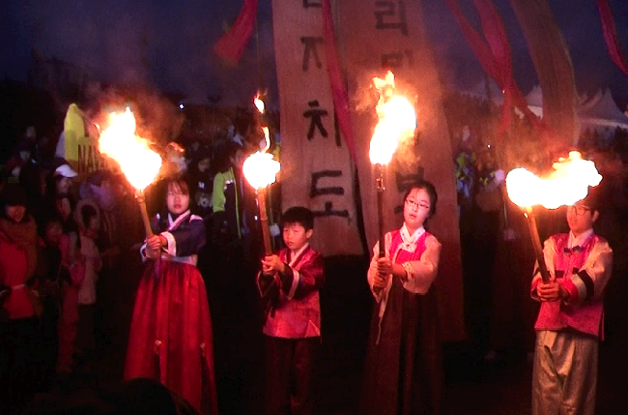

The Jeju Jeongwol Daeboreum Fire Festival takes place in the Saebyeol Oreum area on the full moon day, which falls on the 15th day of the first month of the year. When the festival takes place, farmers and residents will pray for a bountiful harvest, avoid all mishaps, and make business more prosperous than the previous year by preparing the dishes of that season, the fruits. .., and even Kim Chi to offer to the gods.

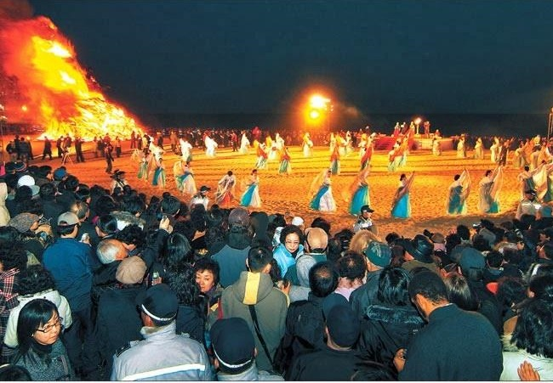

In particular, in the past, there was a custom to light a fire in the field to chase away insects that destroy crops, then feed the cows. Today, the festival also recreates the event of burning fire in the field, along with many other attractive programs such as visiting traditional weddings...

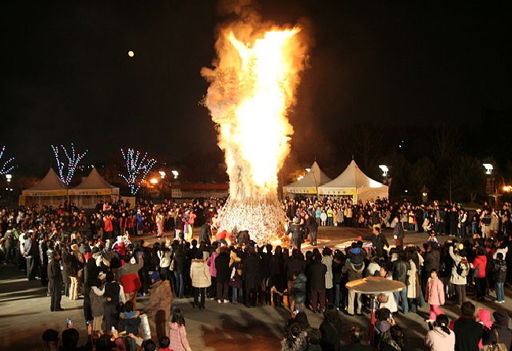

Coming to this festival, visitors will be able to participate in impressive dance performances by the flickering fire, experience the traditional life of the old Koreans and participate in farming, becoming a part of the world. become real farmers.

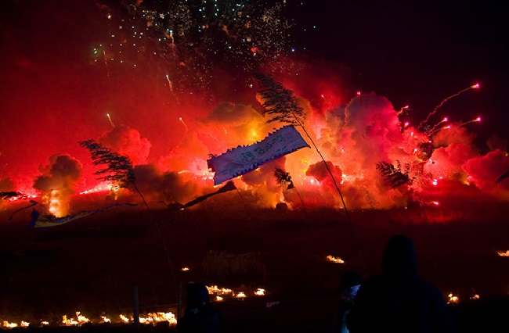

Jeju Jeongwol Daeboreum Fire Festival means a lot to Korean farmers and fishermen, so they have prepared carefully. When the festival was held in the field with many attractive programs, it attracted a large number of tourists to Korea at the beginning of the year.

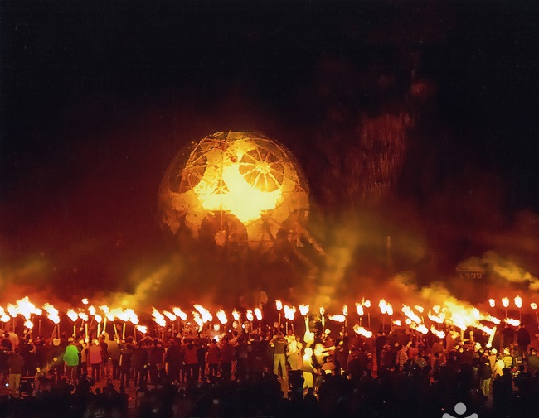

If traveling to Korea on the occasion of the Jeju Jeongwol Daeboreum fire festival, do not miss the opportunity to participate and experience the uniqueness of this traditional festival of the people here!